**Hackathon Project Phases Template**

**Project Title:**

TransLingua: AI-Powered Multi-Language Translator

**Team Name:**

**Code conquerors**

**Team Members:**

* K Karthik
* P Hari krishna
* M Harish
* P Devaraj

**Phase-1: Brainstorming & Ideation**

**Objective:**

* Define the core purpose of TransLingua. (e.g., "To create an AI-powered translator that can seamlessly translate text and speech between multiple languages with high accuracy.")

**Key Points:**

**Phase-2: Requirement Analysis**

**Objective:**

• Develop an AI-driven translator that can provide high-accuracy translations in real-time for both text and speech.

**Key Points:**

**1. AI-Driven Translation Technology**

* **Advanced AI Algorithms**: Uses cutting-edge AI and machine learning models (e.g., Neural Machine Translation) for fast, accurate translations.
* **Contextual Understanding**: Adapts to nuances like idiomatic expressions, slang, and regional dialects, offering more natural translations than traditional systems.
* **Continuous Learning**: Incorporates user feedback to improve translation quality over time.

#### ****2. Multi-Language Support****

* **Global Language Coverage**: Supports a wide range of languages, starting with major global languages (English, Spanish, Mandarin, etc.).
* **Custom Language Pairs**: Ability to translate between many language combinations, both common and rare.

#### ****3. Real-Time Translation****

* **Instant Translation**: Real-time, text-to-text and speech-to-text translation, enabling quick and fluid communication.
* **Voice Translation**: Enables two-way, real-time voice conversations between users speaking different languages.
* **Offline Translation**: Downloadable language packs allow for offline translation, making it functional even without an internet connection.

1. **Technical Requirements:**
   * Programming Language: **Python**
   * Backend: **Google Gemini Flash API**
   * Frontend: **Streamlit Web Framework**
   * Database: **Not required initially (API-based queries)**
2. **Technical Requirements:**
   * Use **Neural Machine Translation (NMT)** or **Transformer-based architectures** (such as GPT, BERT) for generating high-quality, contextual translations.

• Train custom translation models using high-quality, large-scale language datasets.

• Incorporate domain-specific models for translations in legal, medical, or technical fields

• Continuous learning via **Active Learning** to improve translation models based on user feedback.

1. **Constraints & Challenges:**

#### ****Accuracy and Quality of Translations****

* **Challenge**: Ensuring high-quality translations, especially for languages with complex grammar, idiomatic expressions, and cultural nuances.
  + **Solution**: Continuous training of AI models with diverse datasets, real-world usage feedback, and domain-specific models (e.g., medical, legal, technical).
  + **Risk**: Translation errors, especially in less commonly spoken languages, could harm user trust and satisfaction.

**Phase-3: Project Design**

**Objective:**

Develop the architecture and user flow of the application.

**Key Points:** 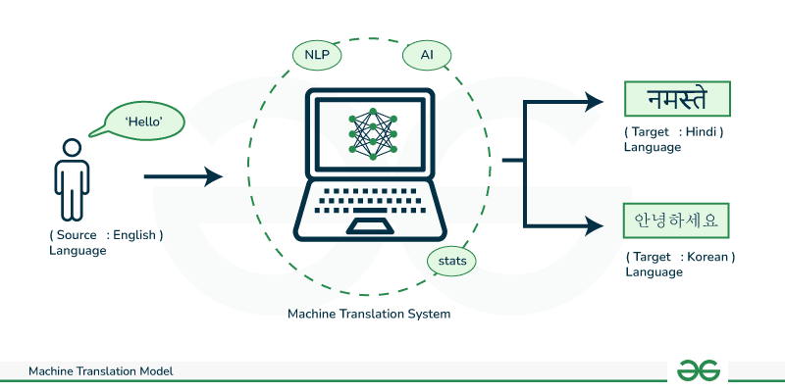

**1. AI-Powered Contextual Translations**

* **Context Awareness**: Utilizes AI to understand the meaning of words and phrases in context, improving accuracy (e.g., distinguishing between different meanings of the same word based on context).
* **Regional Nuances**: Recognizes slang, idiomatic expressions, and regional dialects, offering translations that sound natural and localized.

**2. Multi-Modal Input**

* **Text Input**: Users can type or paste text for translation.
* **Voice Input**: AI-powered voice recognition allows users to speak and get translations in real-time.
* **Image Translation (OCR)**: Users can upload images containing text for translation (e.g., signs, documents).

**3. Multi-Language Support**

* **Wide Language Selection**: Supports a wide range of languages (including rare ones) for both input and output.
* **Automatic Language Detection**: Automatically detects the source language, eliminating the need for manual selection.
* **Continuous Language Addition**: New languages are added regularly based on user demand.

**4. Text-to-Speech (TTS) and Speech-to-Text (STT) Features**

* **Pronunciation Aid**: Translates text and provides an AI-generated voice to pronounce the translated text, improving pronunciation learning.
* **Voice Interaction**: Users can interact with the system via voice, enhancing accessibility and ease of use.

**5. Personalization and AI Learning**

* **User Feedback**: Allows users to rate translations and provide feedback to help improve the system’s AI.
* **Learning Over Time**: AI continuously learns from user feedback, improving translation accuracy and adapting to user preferences (e.g., formality, tone).

**6. Document Translation**

* **File Uploads**: Users can upload documents (PDF, DOCX, etc.) for translation, leveraging AI for accurate translation of complex files.
* **Formatting Retention**: Maintains the original document formatting after translation, ensuring a professional result.

**7. Scalable and Efficient Infrastructure**

* **Cloud-Based**: Uses scalable cloud infrastructure (e.g., AWS, Azure) for fast processing and to handle increasing user demand.
* **Offline Capability**: Some translation features can be used offline for convenience when there’s no internet connection.

**8. User-Friendly Interface**

* **Minimalist Design**: A clean and intuitive UI/UX that focuses on simplicity and ease of use.
* **Cross-Platform Compatibility**: Works across different platforms (web, mobile, desktop) for a seamless user experience.

**9. Privacy and Security**

* **Data Protection**: Ensures user data, including sensitive translations, is encrypted and handled according to GDPR and other privacy regulations.
* **No Data Retention**: Translation data is not stored long-term unless the user opts in for history or feedback purposes.

**10. Advanced Translation Options**

* **Synonym and Suggestion Features**: The AI provides alternative word choices or sentence structures to improve translation quality.
* **Formal vs. Informal Translation**: Users can choose between formal or informal translation tones, especially useful for business or casual communication.

**11. Monetization Model**

* **Free and Premium Versions**: Free version with basic features, premium subscription offering advanced functionalities like document translation, premium voice input, and customization options.
* **API Integration**: Offers an API for businesses to integrate the translation service into their websites, apps, or e-commerce platforms.

**12. Analytics and Insights**

* **User Engagement Metrics**: Track translation usage patterns, feedback ratings, and feature adoption.
* **AI Performance Monitoring**: Continuously monitors and evaluates translation accuracy through AI models to ensure optimal performance.

**Phase-4: Project Planning (Agile Methodologies)**

**Objective:**

Break down development tasks for efficient completion.

|  |  |  |  |  |  |  |  |
| --- | --- | --- | --- | --- | --- | --- | --- |
| **Sprint** | **Task** | **Priority** | **Duration** | **Deadline** | **Assigned To** | **Dependencies** | **Expected Outcome** |
| Sprint 1 | Environment Setup & | 🔴 High | 6 hours (Day 1) | End of Day 1 | Shanawaz | Google API Key, Python, Streamlit setup | Language translator English to Spanish & working |
| Sprint 1 | Frontend UI Development | 🟡 Medium | 2 hours (Day 1) | End of Day 1 | Member 2 | API response format finalized | Basic UI with input fields |
| Sprint 2 | Vehicle Search & Comparison | 🔴 High | 3 hours (Day 2) | Mid-Day 2 | anwar | API response, UI elements ready | Search functionality with filters |
| Sprint 2 | Error Handling & Debugging | 🔴 High | 1.5 hours (Day 2) | Mid-Day 2 | Member 1&4 | API logs, UI inputs | Worked for error handling |

**Sprint Planning with Priorities**

**Sprint 1 – Setup & Integration (Day 1)**

**(🔴 High Priority)** Set up the **environment** & install dependencies.  
 **(🔴 High Priority)** Integrate **Google Gemini API**.  
 **(🟡 Medium Priority)** Build a **basic UI with input fields**.

**Sprint 2 – Core Features & Debugging (Day 2)**

**(🔴 High Priority)** Implement **search & comparison functionalities**.  
 **(🔴 High Priority)** Debug API issues & handle **errors in queries**.

**Sprint 3 – Testing, Enhancements & Submission (Day 2)**

**(🟡 Medium Priority)** refine UI, & fix UI bugs.  
 **(🟢 Low Priority)** Final **demo preparation & deployment**.

**Phase-5: Project Development**

**Objective:**

Implement core features of the AutoSage App.

**Key Points:**

1. **Technology Stack Used:**
   * **Frontend:** Streamlit
   * **Backend:** Google Gemini Flash API
   * **Programming Language:** Python
2. **Development Process:**
   * Implement **API key authentication** and **Gemini API integration**.
   * Develop **vehicle comparison and maintenance tips logic**.
   * Optimize **search queries for performance and relevance**.
3. **Challenges & Fixes:**
   * **Challenge:** Delayed API response times.  
      **Fix:** Implement **caching** to store frequently queried results.
   * **Challenge:** Limited API calls per minute.  
      **Fix:** Optimize queries to fetch **only necessary data**.

**Phase-6: Functional & Performance Testing**

**Objective:**

Ensure that the AutoSage App works as expected.

|  |  |  |  |  |  |
| --- | --- | --- | --- | --- | --- |
| **Test Case ID** | **Category** | **Test Scenario** | **Expected Outcome** | **Status** | **Tester** |
| TC-001 | Functional Testing | Query "English to french" | English to French translated should be displayed. | ✅ Passed | Tester 1 |
| TC-002 | Functional Testing | Query "English to any language" | Available languages should be provided. | ✅ Passed | Tester 2 |
| TC-003 | Performance Testing | API response time under 500ms | API should return results quickly. | ⚠ Needs Optimization | Tester 3 |
| TC-004 | Bug Fixes & Improvements | Fixed incorrect API responses. | Data accuracy should be improved. | ✅ Fixed | Developer |

**Final Submission**

1. **Project Report Based on the templates**
2. **Demo Video (3-5 Minutes)**
3. **GitHub/Code Repository Link**
4. **Presentation**